Homecare Analyzers

Maxtec is the leading supplier of analyzers to the homecare market. Our technology provides long-life sensors and excellent battery life, cutting maintenance and battery replacement costs in half when compared to other products in the industry.

- 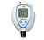MaxO2+A
- 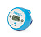Handi+
- 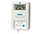OM-25A
- 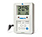OM-25ME
- OM-25MEL
- 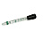FlowCheck

MaxO2+A
Part Number: R217P62
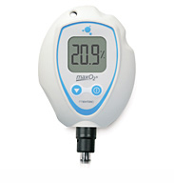
24 month warranty
Œ
The MAXO₂+A was designed with simplicity and portability in mind. This analyzer is ideal for checking oxygen percent accuracy in concentrators.

- 24 month warranty on both the analyzer and the sensor
- Internal MAX-250+ Long Life Sensor
- 5,000+ hours operation on 2 AA batteries
- Easy one touch calibration
- Patented ergonomic design fits comfortably in your hand
- Quickly adapts to bore tube applications

- Data Sheet
- Comparison Chart
- Manual
- Specifications
- Frequently Asked Questions

Part Numbers
MaxO2+A with FlowCheck Adapter
R217P62-004

Hide Available Accessories
Back to Top

Available Accessories
Blue indicates accessory comes standard with purchase.
- 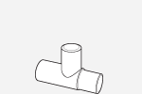
15mm Tee Adapter
[ RP16P02 ]
- 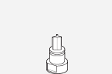
Flow Diverter
[ R110P10 ]
- 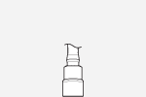
Barbed Adapter w/tubing
[ R207P17 ]
- 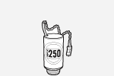
Replacement MaxO2+ Sensor
[ R125P02-011 ]
- 
Lanyard
[ RP76P06 ]
- 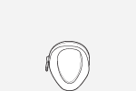
Tight Fit Case
[ R217P32 ]
- 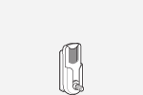
Belt Clip Assembly
[ R217P22]
- 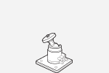
Swivel Mount
[ R213P31 ]
- 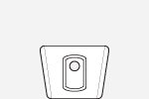
Dovetail Assembly
[ R217P23 ]
- 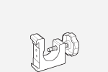
Pole Mount
[ R206P75 ]
- 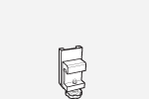
Rail Mount
[ R100P10 ]
- 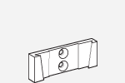
Wall Mount
[ R205P86 ]
- 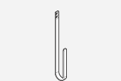
Accessory Hook for Pole Mount & Rail Mount
[ R200P03 ]
- 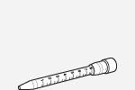
FlowCheck
[ R217P18 ]
- 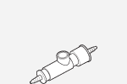
Perfusion Adapter
[ R103P90 ]

